22 April 2015

Germany and the Eurozone: Beauty and the Beast

The eurozone is still wrestling with the problem that has bedevilled it from the beginning: it lacks sufficient institutional arrangements to become a well-functioning currency union. A symptom of this is that the monetary and fiscal needs of its largest economy – Germany - are quite different to those of many other members. The issue is exacerbated by the particular sensitivity of the Bundesbank to the inflation threat. Not surprisingly, the marriage of a competitive German economy with weaker members of the club remains a tempestuous one.
The history of the eurozone currency union has been dominated by the tensions that a common monetary policy has provoked. One of the most profitable trades of the second half of the nineties was playing the convergence in eurozone bond yields, as the market rerated historically humdrum credits, such as those countries that now constitute the periphery, down to German levels. The Italian 10-year bond yield fell from 13.4% in April 1995 to 4.0% by the end of 1998, just 0.25% above Bunds. This collapse in the cost of money stoked the real estate boom that ended so painfully in 2008 for Spain and Ireland. But why were eurozone rates kept so low after the eurozone was created in 1999? In part to suit Germany, then the sick man of Europe, struggling with high unemployment and a need for structural reform.
Fast-forward to today, and the eurozone faces the opposite version of the same problem, with monetary policy still disproportionately influenced by the needs of Germany. It has transformed its competitiveness, government finances are sound, and the economy has grown faster than the rest of the eurozone every year since 2010. The contrast between Germany and the rest is stark when looked at through the prism of spare capacity, and the deflationary forces this implies for the eurozone-ex Germany versus the potential for overheating in Germany (See Chart 1).
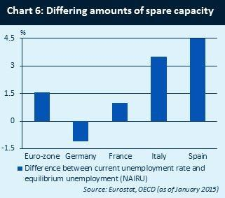
For example, German industry has demonstrated that it can comfortably cope with a euro/US dollar exchange rate of 1.40, with margins close to a cyclical peak, in stark contrast to the rest of the region where margins are closer to 2008 lows.

The domestic economy is vibrant, supported by falling unemployment which is now at the lowest level since reunification, and at 4.8% some distance below the OECD’s estimate of the non-inflationary rate of 5.9%. Unemployment in the eurozone excluding Germany stands at 14.1%. Wage inflation is already rising as employers struggle to attract new workers, with the 3.4% deal won by metalworker union, IG Metall, in Baden Wurttemberg in March a portent for the future. The housing market has seen a marked appreciation, driven by the above factors and the record low cost of financing, while household sentiment is soaring (See Chart 2).
German consumer confidence and house prices, lagged by 6 months
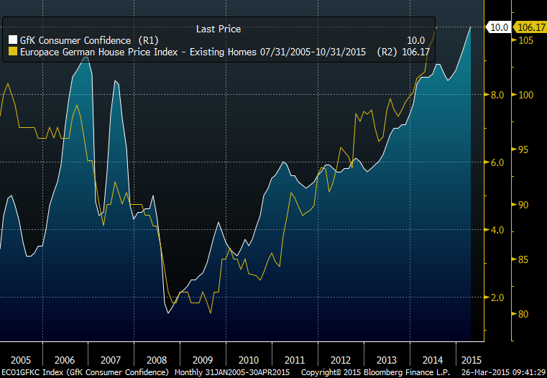
This is clearly an economy for which a further large stimulus was unnecessary and potentially damaging if left in place for too long. Nonetheless, the Bundesbank’s aversion to QE was unable to stop the ECB adopting large scale asset purchases. Asset prices have responded with an almost unprecedented surge, and the euro, already weak in anticipation of such a policy move, has fallen further. An already strong German economy with little spare capacity is being turbo-charged by the triple shock of a 22% fall in the euro, a further cheapening of the cost of money, and the halving of the oil price. Little wonder that senior figures in authority are already uncomfortable: the President of the Bundesbank, Jens Weidmann, has recently warned on the overvaluation of urban housing, and the Minister of finance, Wolfgang Schauble, has commented that very low interest rates are causing huge problems for Germany as resources become misallocated and bubbles develop.
In the short term investors can ignore German angst, and enjoy the liquidity party. Eurozone equities are still relatively attractively valued, and likely to rise further as economies expand once more, driving earnings upgrades. The euro is unlikely to appreciate for any meaningful length of time, and may weaken further as interest rate differentials widen as the US begins to tighten monetary policy at last. Even bond yields at current eye-watering levels may get richer, such is the technical squeeze of ECB QE.
However, the history of monetary policy in the eurozone should not be forgotten. An overheating German economy could lead to increasingly loud calls for a change in direction. In a year’s time it might well be apparent that Germany needs tighter monetary policy and an end to QE or at least tapering of the programme. The rest of the eurozone is highly unlikely to agree so tensions will rise and policy decisions will become increasingly complicated. This may call into question the current consensus on the longevity of QE and therefore the appropriate level for eurozone assets. In the long term 10-year Bunds at 0.2% look dramatically over-valued when measured against the domestic growth and inflation outlook. Any further depreciation of the euro will at the very least be questioned, and the currency may eventually appreciate. For equities an outlook of the ending of QE, rising bond yields, and potentially a rising currency would be an unpalatable mix. The current optimism is contingent on QE remaining in place, but if Germany decides that a different monetary policy is appropriate the cosy consensus may have to adapt.
Neil Richardson, investment director, Standard Life Investments

