Steen's Chronicle: Fed delivery too little, too late — USD boosted

By Steen Jakobsen, Chief Economist & CIO / Saxo Bank
Denmark
- Fed will either hike or set market up for hike in September
- Be underweight US fixed Income and credit
- Be long US dollar against all currencies but mainly against basket
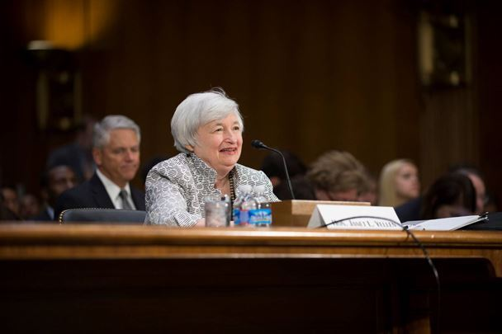
The Jackson Hole event starting this week is the key event of the summer and Fed
chair Janet Yellen will be outlining her next step on Friday. Photo;: iStock
By Steen Jakobsen
First off, there are some general trading themes resulting from the likely moves of the Federal Reserve over the coming weeks.
Trades
• Long DXY @ 94.40 stop 91.70 on daily close
• Short silver & gold
• Underweight 10-year and 30-year US Treasuries
The Dollar Index should be on the rise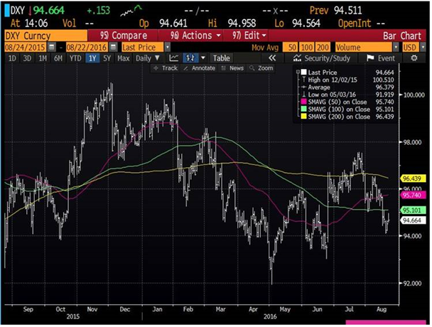
Source: Bloomberg
No world's end
Brexit didn't end the world despite the dire warnings of policymakers and politicians, and it's interesting to observe that the only time the world is 'going under' is when the voters, the supposedly real power of any democracy, decide against the elite and establishment. The concept of free markets is constantly under attack from central banks implementing 'short-term support to markets' to government bank rolling any future risk.
The last sentence is a link to the Economist's piece this weekend 'Comradely Capitalism' about the US mortgage market which is now almost entirely guaranteed by the US government without any capital buffer. The 2008/09 crisis has simply moved mortgages off the books of the banks and into the hands of the US tax payer to the tune of a potential negative 2-3% GDP loss (similar size to the 2008/09 crisis)
Basically, to help the world in 2008/09, the US government took off the US mortgage market, in the process ending the market-based origination of debt and leaving banks unable to compete. Zero market, zero capitalism, but a lot of macro-prudential policies.
The total size of the US mortgage market exceeds the US stock market by far. Talk about a hidden risk embedded in a macro-prudential framework.
Astonishing consensus
Now we are on the subject of risk, I find it astonishing how consensus is projecting markets. I remember firmly during the fourth quarter of 2015 when I was talking about how a Fed hike cycle almost always leaves the US dollar weaker 12 months later.
Furthermore I pointed out how gold and EMG will be the best performing assets - this wasn't my prediction but based on Allianz's excellent report: ‘Historical lessons from Federal Reserve rate hike cycle”, which I have mentioned several times before. At the time I was looked at as having two heads and consensus was for a dramatically stronger US dollar in 2016.

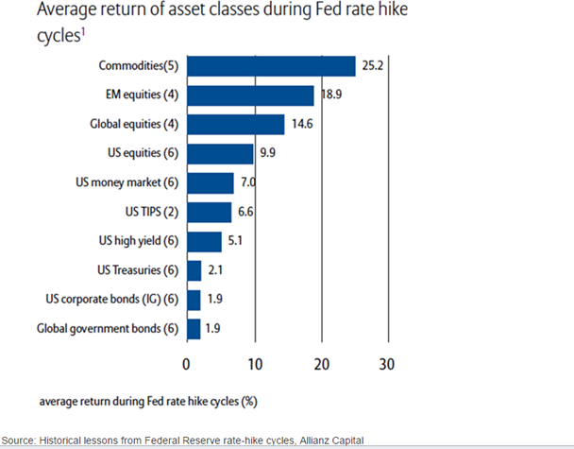

My main reason for bringing up the weaker US dollar was that I expected US growth to be below par and more so, the more the Fed delivered in terms of actual hikes, but the market saw and believed only in the Fed’s strong rhetoric which at the time promised, even guaranteed four hikes in 2016.
Now fast forward to today, the market firmly believes in a much weaker dollar at what I consider the low point in the US growth cycle. Yes, there is some political unrest regarding the US election, but in the land of facts, the US monetary policy is not only tighter but showing signs of early stress (which is wholly ignored by both the credit and bond market for now….).
Three-month Libor is higher than two years US/ the TED spread is sending out small stress signals, the excess of the pool of non-dollar is falling with lower oil prices and delinquencies are rising with the banks. Top this off with the leading indicator of the credit cycle: Senior Loan Officers Survey from the Fed, which shows tighter credit through the last three quarters.
TED spread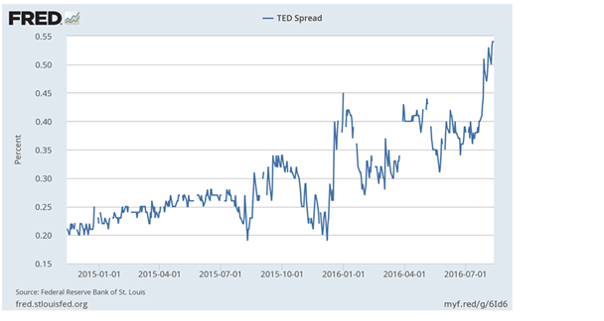
Source: Federal Reserve Bank of St Louis
The LIBOR three-month & two-year US government yield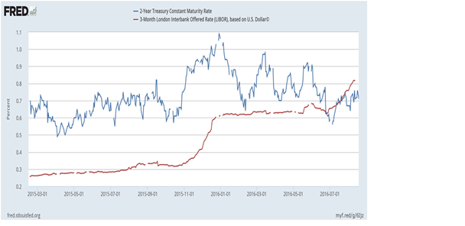Source: Federal Reserve Bank
Defaults have doubled, and delinquencies are showing “some issue” incoming….
Parallels with 2008
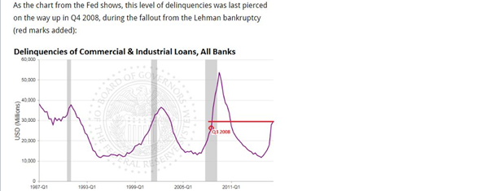Source: Wolf Street
Meanwhile another leading credit cycle indicator – The senior loan officers survey from Fed clearly indicates banks are less willing to lend – which leads rates higher……
Cost of lending rising
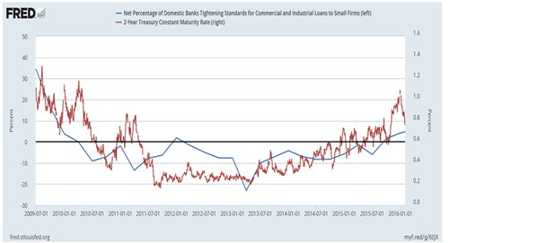

Source: Federal Reserve
Credibility deficit
Yes, unlike in early 2016 when the Fed could not deliver hikes, the market is now delivering hikes into a stock market trading at all-time highs, while housing prices are finally back at their peak - it all makes sense except for the markets expectation for a weaker US dollar.
The key event this summer is Jackson Hole, where Fed chair Janet Yellen is expected to announce her next step on August 26. Fed communication is almost 100% a waste of time as the only rule which makes you money in central watching is to ignore what they say, and act on what they do which most often is nothing.
However, there is strong case for a September hike or at least pre-announcing an October hike. The first argument is that credit conditions already reflect this. The second is to create some room for the drop in rates which have to come by early 2017 in tandem with getting something out before US election in November.
Finally, the Fed, although not to be trusted, is clearly determined even in its communication to continue its path higher in rates and even it knows talking about it will no longer will do the job. Only action will talk and create a much needed increase in the bank's credibility which is mighty close to zero with the market.
The most important aspect however remains the most primitive argument - the fact the stock market trades at an all-time high is a temptation it can not ignore.
In recent history, interest rate cuts have always been preceded by intermediate lows in stock markets, now it's likely the Fed will create reciprocity by hiking rates on new highs. It fits the Fed's primitive world of economics, where policies are measured not on how they do for the economy but how they do for Wall Street and the stock markets.
The lack of direction and understanding was for all to see in this weekend’s speech by Vice-Chairman Stanley Fischer at the Aspen Insitute
This is comment on the internal email:
“Reading full speech and....Fischer prepares for hike with inventories being the excuse but his productivity part is the most interesting from an economics perspective as he simply thinks a lack of productivity is mainly because we don't measure it correctly – the closing part of his speech supporting more fiscal policy is a conclusion of pretend and extend from a ‘tired central bank’ which desperately holds on to his and the Fed's belief that it understands the mechanics of the economy which it clearly doesn't.......”
Harsh, you may say, but the Fed has pretty much given up understanding the economy in a situation where it has been to “easy” for too long with nothing to show for it, except the stock market valuation and all its unintended consequences – risking a bit of that “success” is the next step for the Fed and hence my two biggest calls remains:
Underweight US fixed income (and credit) – and long US dollar through this cycle where the market is lagging behind in its adjustment to a Fed desperate to normalise……
Does the Fed even understand the mechanics of the economy? Photo: iStock

— Edited by Martin O'Rourke
Steen Jakobsen is chief economist and CIO at Saxo Bank

